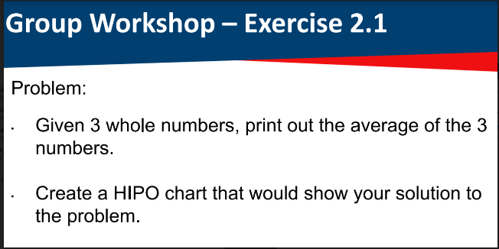

John Asher M. Manit

BSCS 1A

Average

Number 1,

Number 2,

Number 3.

.

1. Get number 1, number 2, and number 3.
2. Add all the given numbers to get the sum.
3. Divide the sum by the count of given numbers to get the average.
4. Display the average

OUTPUT

PROCESS

INPUT